**Untitled GUI Game**

**Design Document and Testing Report**

Luke Stanbridge

19 August 2022

Purpose

For this project I want to design and implement the UI system for my game I am intending to make in Cross Platform Development. Doing this should save me a lot of time in the future and I can solely focus on the game loop development as the UI will already be complete. I will require a MAIN MENU, PAUSE MENU and IN-GAME UI to be developed for my game idea.

Requirements

A decent gaming PC

Unity

Visual Studio 2022

Figma

Features

MAIN MENU – The main menu screen will contain buttons for….

* Starting the game, which will transition the player to the game scene (on click event).
* Loading the game, which will load the player into their previously saved checkpoint (on click event).
* Settings option, which will bring up a settings screen that the player can adjust settings, this will contain things like music volume(slider), SFX volume(slider), audio visualizer display (check box), difficulty level (drop down menu). Also contains a back button (on click event) to return player to the main menu.
* Credits option (not entirely necessary) will display references for all contributions to the game as readable text, with a back button (on-click event) that takes you back to the main menu.
* How to play option that will give the user information about the game’s controls and the objective of the game. This will bring up a subsequent menu that displays all this information.
* Exit option will close the application (on-click event).

PAUSE MENU – The pause menu will contain buttons for…

* Resume the game, this will allow the player to continue playing the game (on-click event).
* Restart the game, takes the player back to the start of the game (on-click event).
* How to Play, which will display the controls scheme and goals for the player, and a back button (on-click events)
* Settings, which displays the same settings options that were displayed in the main menu (on-click event).
* Quit Game allows the player to exit back to the main menu screen (on-click event)

IN-GAME UI – The in-game UI that will be displayed is…

* Lives remaining which will be a Lives counter display in the top right corner
* Timer for the player to see how quick they can complete the level or a set timer that counts down to zero and the player will fail if they don’t complete in the allotted time frame. Might make this a difficulty option.
* Audio visualizer(optional) in the bottom right corner so you can still see when the music is getting louder even if the sound is very low.

UI Wireframe Mockups

I like this design layout for the **Main Menu** and want to roughly stick this layout.

* 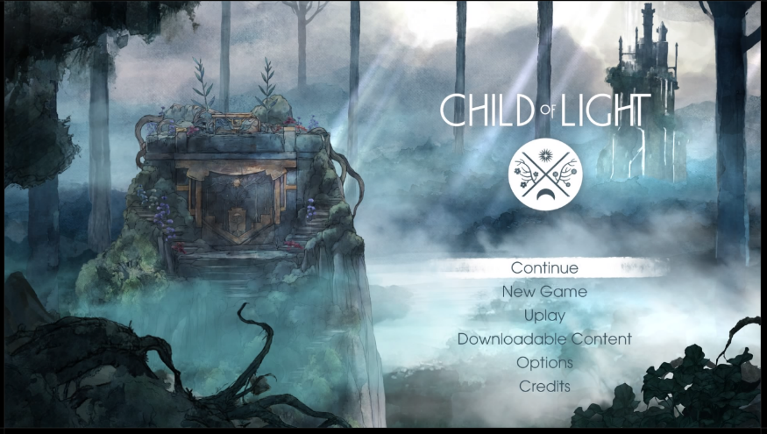**Title** at the top of the game, might offset it from center depending on what background options I decide to go with.
* **Background** will be an image relevant to the game. Hopefully some nice artistic piece and maybe animations in it. I like the idea of some movement in the background.
* **Selection Options** will be placed beneath the title of the game, they will have clear labeling and descriptions that pop up in association with the option that is highlighted so the user understands what each option does. The ‘settings’, ‘load game’ and ‘how to play’ options will bring up subsequent menus next to the options so the user can engage with these features.

For the **Pause Menu** this sort of layout is what I plan to roughly implement.

* **Title** centered at the top of the options menu saying that the game is paused.
* A screenshot of a video game

  Description automatically generated**Background** will be a black transparent overlay on top of the game with the game frozen in the background, player movement and timer stop until game is resumed.
* **Selection Options** will be the same options and layout from the main menu with only small tweaks to the play and quit buttons/descriptions. Wanted to keep this design similar the main menu to be consistent and avoid confusion for the user.

For the **in-game HUD** I’m not sure exactly how I want the game to operate so I am leaving this very basic for the time being. Plan to update and add something better during cross platform development.

* **Timer** in the top right-hand corner that counts when you start the game and pauses when you hit the pause menu.
* **Player Lives** display which shows the user how many lives remain in the top left-hand corner.

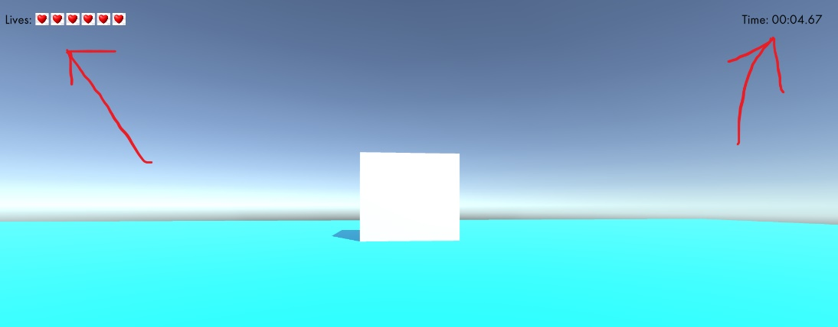

Testing Report

* Body panels wouldn’t reset to default blank screen in Pause Menu when exiting out of pause and then going back in. Had to implement a function in “TabGroup” script to fix this.
* Body panels for the load, settings and how to play options needed to stay active when dragging the mouse across the other tab options. Implemented a function in the “TabGroup” script to control this.

Feedback

* Add tweening animations to tab options so they pop out a bit when the mouse is on the tab
* Add tweening to make the body panel appear in a transition instead of just appearing when you hover over the tab.
* Q and E button functionality
* Add a title for the game.
* Change placeholder photos to something relevant to the game.
* Scale pause menu so it is slightly smaller than main menu.
* Add background music
* Change music sliders to a better option

\**Note*\* - Need to fill up the top tabs with meaningful content otherwise the UI may need to be changed when implemented for a proper game. Currently only one tab has all the game menu functionality in it. I used the other tabs to create a few other Menu mock-ups. If needed I have plenty of space to put more options and functionality into the Menu. Currently I don’t think I will use it all. Left it all there as I liked the layout and would like to figure out a way to use it in the current format.